Community Clothes Swap Event
Islington Sustainability Fair , 24th August, 2 – 5pm at Islington Assembly Hall, Upper St, N1 2UD
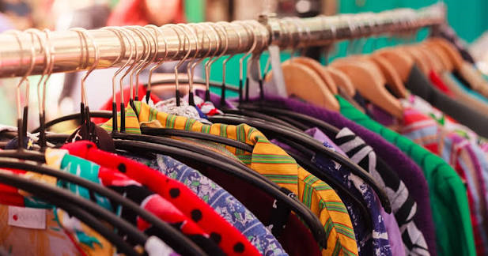
Give your pre-loved clothes a second life and discover new-to-you fashion at our Clothes Swap Event! This is a great opportunity to refresh your wardrobe sustainably, reduce waste, and connect with others in the community.
How It Works
Bring along clean, good-quality clothing and accessories to exchange for swap tokens. You can then use your tokens to choose items brought in by other participants.
Items Donated | Tokens Received
1 Item | 1 Token
5 Items | 5 Tokens
10 Items | 10 Tokens

We Accept
- Clean clothing in good condition
- Shoes
- Bags
- Accessories

We Cannot Accept
- Damaged items
- Underwear
- Swimwear
- Uniforms
- Heavily stained clothing

Event Guidelines
To ensure a fair and enjoyable experience for everyone:
- One token is required per item.
- Please respect any swapping limits in place.
- Items cannot be reserved.
- Be considerate of fellow participants.

