23rd August 2022

ISN members post their carbon data for 2021/22
Many thanks to all ISN members who have participated in the annual carbon monitoring exercise, covering 2021/22. For a lot of organisations, the global pandemic had resulted in a couple of years of significant disruption, a downturn in economic activity and the impacts of employees working remotely. As such, the previous two years carbon data has fluctuated for many and proven an anomaly for some members with significant emission reductions been reported in 2020/21 followed by a slight increase again this year to coincide with a return to ‘normal productivity’ trends.
Despite these fluctuations, in 2020/21, the total emissions by members who reported again this year have reduced by 17%. Overall, ISN members have now carried out 41,849 tonnes CO₂ savings through energy efficiency measures since we began capturing data in 2006. 69% of members recorded significant reductions from their baseline.
In addition to this, 63% of reported members are now on renewable electricity tariffs - we’ll still be looking to improve on this in the next year and encouraging the participation in our Big Clean Switch scheme, though fully aware of the current high energy costs and lack of competitive green tariffs available.
In recent years, ISN spent time developing a new carbon monitoring tool, expanded to include Scope 2 and 3 emissions – we continue to get positive feedback with more members now reporting on waste, water and transport especially.
ISN members represent over 15% of the borough’s commercial carbon emissions. Individual annual reports are to be sent out to all members who responded.
Overall emissions in Islington 2005- 2020
The data for carbon emissions for UK districts is produced by central government and is released two years in arrears, meaning the latest data released in 2022 was for the year 2020¹.
It should be noted that the BEIS dataset has changed this year. Rather than reporting on carbon dioxide emissions alone it now provides data on a set of greenhouse gas emissions (carbon dioxide, methane and nitrous oxide). There has also been a change in the units used to report emissions – previously they were reported as tonnes of carbon dioxide (tCO2), now they are reported as tonnes of carbon dioxide equivalent (tCO2e). Using units of carbon dioxide equivalent allows comparison between different greenhouse gases based on their global warming potential.
Headline figures
- Total greenhouse gas emissions in Islington reduced by 53% between 2005 and 2020
- Per capita greenhouse gas emissions fell by 65% (Islington’s population rose by 35% in this period)
- Islington’s reduction is above the London (47%) and national average (43%)
- Emissions decreased in all three main sectors (commercial, residential and transport)
The reduction in emissions in Islington has been achieved despite significant population growth. Between 2005 and 2020, Islington’s population rose from 183,477 to 248,115, a 35% increase. Taking this into account, our per capita emissions have dropped even further than the 53% total figure – falling from 6.9 tonnes per person in 2005 to 2.4 tonnes per person in 2020, a decrease of 65%.

The national dataset breaks down the greenhouse gas emissions into three main sectors: commercial and industrial, residential and transport. According to the latest figures from 2020, the commercial and industrial sector is the largest contributor to emissions in Islington, accounting for 41% of the total. Residential properties account for 39% and transport for 20%. The latest dataset also breaks down the commercial and industrial sector into commercial (27%), industrial (4%) and public sector (9%).
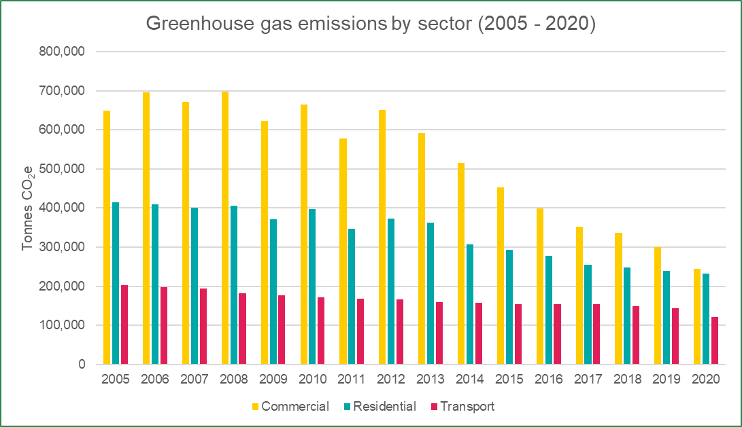
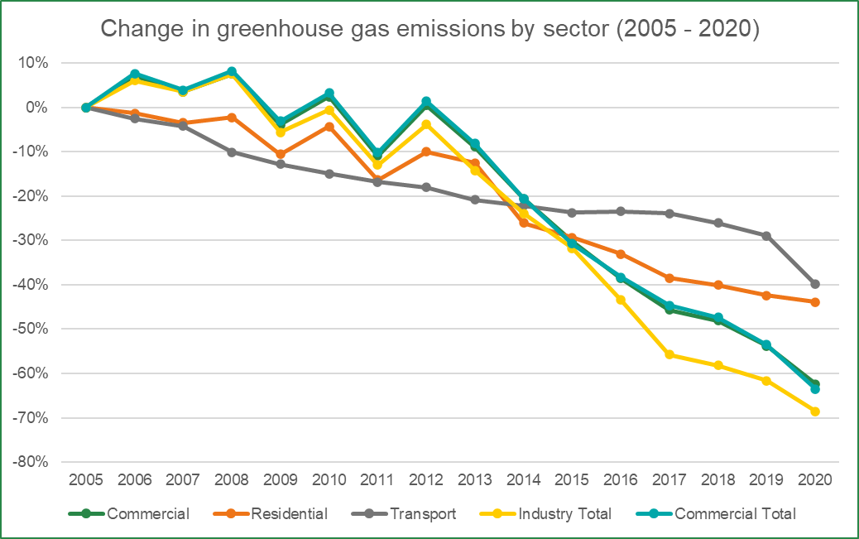
Greenhouse gas emissions have reduced in all three sectors over the period 2005-2020; commercial and industrial emissions reduced by 62%, residential emissions by 44% and transport-related emissions by 40%. Within the commercial and industrial sector, industrial emissions fell by 69%, commercial by 64% and public sector by 54%.
Part of the reason for the differences between sectors is the rapid decarbonisation of the electricity grid, which saw its carbon intensity reduce by 64% between 2005 and 2020 (meaning that even if electricity consumption had remained static, electricity-related emissions would have fallen by 64%).2 Electricity accounts for a greater proportion of emissions in the commercial sector (54%) than in the industrial (39%), public (36%) or residential sectors (27%), meaning that the commercial sector has seen a more significant drop in its emissions.

Comparison with elsewhere
The reduction in emissions in Islington between 2005 and 2020 are higher than both regional and national averages, as shown in the table below. The overall reduction in emissions (53%) was the 22nd highest of the 374 districts in the country (up from 24th last year), whilst the per capita emission reduction was the 10th highest (up from 11th).

Area | Total carbon emissions change | Per capita carbon emissions change
Islington | -53% | -65%
London | -47% | -56%
England | -44% | -50%
UK | -43% | -49%

UK local authority and regional greenhouse gas emissions national statistics, 2005 to 2020
2 UK local and regional greenhouse gas emission estimates for 2005–2020: Technical Report, p13

